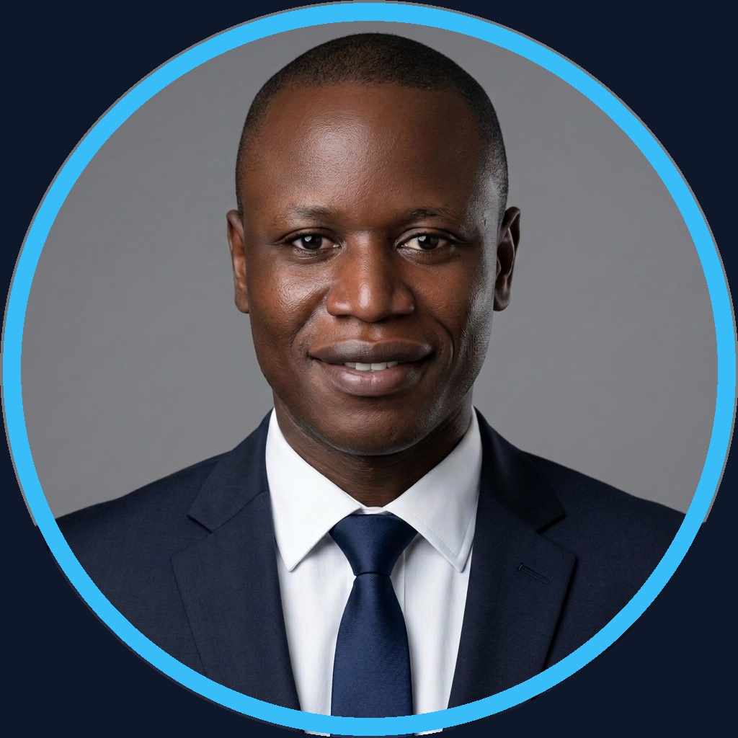  ◈ LEAD AI ENGINEER  Founder · Archi Cam AI  CONTACT & PROFILES  ━━━━━━━━━━━━━━━━━━━━  ✉ magenel85@gmail.com  ✆ +237 695 35 34 02  ⌂ Douala / Ngaoundéré, CM  🌐 github.com/gervais-afk  💼 linkedin.com/in/marie-gervais-koa  ⚡ devpost.com/magenel85  🏅 Google Developer Program  AI & LLM STACK  ━━━━━━━━━━━━━━━━━━━━  Google Antigravity IDE ■ ■ ■ ■ ■  LangGraph & WikiSkills ■ ■ ■ ■ ■  Google Gemma 4 (12B) ■ ■ ■ ■ ■  Gemini 2.5 / 1.5 Pro ■ ■ ■ ■ ■  Google TabFM (Tabular) ■ ■ ■ ■ ■  Firebase Genkit ■ ■ ■ ■ ■  Neo4j GraphRAG — Agent K1  DATA & GRAPHS  ━━━━━━━━━━━━━━━━━━━━  Neo4j / Cypher Graph ■ ■ ■ ■ ■  PostgreSQL / pgvector ■ ■ ■ ■ ■  Google BigQuery ■ ■ ■ ■ □  Supabase Realtime ■ ■ ■ ■ □  Pandas / NumPy ETL ■ ■ ■ ■ ■  DEV & MLOPS  ━━━━━━━━━━━━━━━━━━━━  Python 3.11+ / MLOps ■ ■ ■ ■ ■  FastAPI / Next.js 14 ■ ■ ■ ■ □  MLflow & Data Drift ■ ■ ■ ■ □  SHAP Sentinel Audit ■ ■ ■ ■ ■  Docker & Streamlit ■ ■ ■ ■ ■  IfcOpenShell (5D BIM) ■ ■ ■ ■ □  ETHICS, SECURITY & AUDIT  ━━━━━━━━━━━━━━━━━━━━  ◈ AI Ethics & Anti-Hallucination  ◈ Quorum 4-Eyes Governance  ◈ OKF v0.2 SHA-256 No-LLM  ◈ EU AI Act Compliance (RSASSA)  ◈ AVSEC (ICAO Annex 17)  LANGUAGES  ━━━━━━━━━━━━━━━━━━━━  French — Native / Fluent  English — Functional basics (tools & doc.)  KEY ASSETS  ━━━━━━━━━━━━━━━━━━━━  ◈ Dual Competence: AI & Civil Eng.  ◈ Aviation Security & Crisis (CCAA)  ◈ Mathematical Rigor & Guardrails | KOA MARIE GERVAIS NELLY  Lead AI Engineer & Data Architect │ Founder @ Archi Cam AI  ──────────────────────────────────────────────────────────────────────  ◈ EXECUTIVE SUMMARY  ━━━━━━━━━━━━━━━━━━────────────────────────────────────────────  Lead AI Engineer & Data Architect (Google Developer Program Member), leveraging Google Antigravity to design neuro-symbolic multi-agent architectures, Neo4j GraphRAG, and sovereign MLOps pipelines. Expert in AI ethics: SHAP transparency, EU AI Act compliance, and deterministic zero-hallucination models. Founder & Architect of Archi Cam AI (Agentic AI SaaS & 5D BIM), bridging civil engineering methodology, mathematical rigor, and product vision.  ◈ FLAGSHIP AI PROJECTS  ━━━━━━━━━━━━━━━━━━────────────────────────────────────────────  Archi Cam AI — Agentic AI SaaS & 5D BIM  ▸ Sovereign 5D BIM & BOQ estimation platform engineered with Google Antigravity (Gemma 4 12B, Gemini 2.5, BAEL 91).  ▸ Automated Excel BOQs in <45s (–99.2% time, MLflow R²=0.9872) and 3D renders via Imagen 3 + ControlNet.  ▸ IfcOpenShell integration for 5D BIM models: automated costing & scheduling via LangGraph agents.  K1-MATHINFO (v3.0.0) — Sovereign Multi-Agent AI, WikiSkills & OKF Certification  ▸ Sovereign DMI system (Univ. of Ngaoundéré): 470 theses, 19 M1 projects, 1,366 Neo4j nodes.  ▸ 6 LangGraph agents orchestrated via WikiSkills (critic anti-hallucination, Cypher optimizer), RRF k=60, SHA-256 No-LLM (100%).  Sovereign.BI Agentic — Enterprise Security & Agentic BI  ▸ NL-to-SQL/Graph engine (PostgreSQL pgvector, Neo4j N10S, <5s latency) with ABAC guardrails + SHAP Sentinel.  ▸ Interactive executive dashboards via Streamlit & FastAPI — deployed on sovereign Docker cloud.  Dataset Automator & VigieSahel — MLOps Pipeline & Climate AI Impact  ▸ Dataset Automator: Google Antigravity (Google Cloud Hackathon) — TabFM, BigQuery DataFrames, EU AI Act.  ▸ VigieSahel: –35% crop loss, +14d epidemic forecast (XGBoost R²>94%, Supabase, MLflow).  ◈ PROFESSIONAL EXPERIENCE  ━━━━━━━━━━━━━━━━━━────────────────────────────────────────────  AI Lead & Data Science Consultant — March 2026 – Present  Independent Projects & Enterprises │ Douala, CM  ▸ Ethical sovereign AI systems: GraphRAG Neo4j pipelines, high-dimensional EDA, multi-source RAG architectures.  ▸ Executive decision reporting, automated KPI dashboards, and SHAP explainability audits for African SMEs.  Aviation Security Officer (AVSEC) — 2018 – Present  CCAA — Cameroon Civil Aviation Authority │ Douala, CM  ▸ Threat assessment, secure access control, and regulatory compliance audits (ICAO Annex 17).  ▸ Operational crisis management: emergency team coordination, anti-intrusion protocols.  ◈ EDUCATION & CERTIFICATIONS  ━━━━━━━━━━━━━━━━━━────────────────────────────────────────────  M.Sc. in Applied Artificial Intelligence — Dec. 2025 – 2027 [In Progress]  University of Ngaoundéré │ Cameroon  ▸ ML & Bayesian Statistics, Data Engineering & Neo4j, Computer Vision & Robotics, Ethics & Cybersecurity, Production MLOps.  ▸ Research project: K1-MATHINFO v3 sovereign system — multi-source agent certified OKF v0.2 (SHA-256 No-LLM).  B.Sc. in Civil Engineering (Building Option) — 2015 – 2016  ISTDI / IUC Douala │ Cameroon  ▸ Structural calculations (BAEL 91), quantity surveying, construction project management — AI-applied estimation base.  ◈ HONORS & APPLIED AI DISTINCTIONS  ━━━━━━━━━━━━━━━━━━────────────────────────────────────────────  ◈ CCAA Certificate of Excellence & Integrity (2023) — Awarded by the Director General for outstanding operational performance & ethics.  ◈ Google Cloud #AllThingsAgentic Hackathon — Dataset Automator v4.0 (Google Antigravity, TabFM, BigQuery DataFrames, WIT).  ◈ Google Developer Program · Devpost — Active member — AI open-source contributions, hackathons & sovereign AI architect.

